Online Sales SQL Analysis Report
This report contains SQL query outputs and business insights from the Online Sales dataset.

Total Revenue
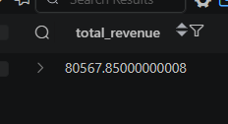

Total Units Sold


Average Unit Price
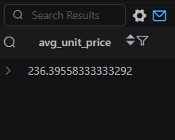

Revenue by Product Category
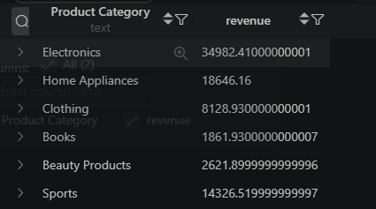

Revenue by Region
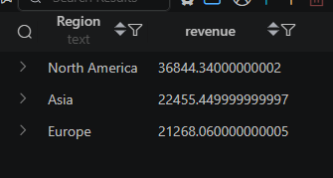

Revenue by Payment Method
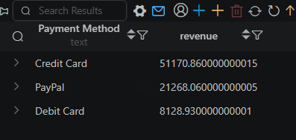7

Monthly Revenue
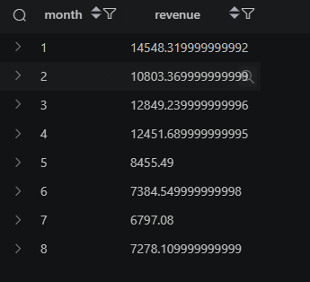

Top Products by Revenue
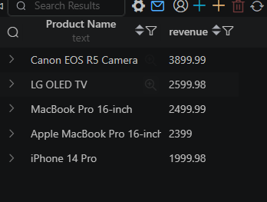

Highest Revenue Transaction

Product Revenue Ranking
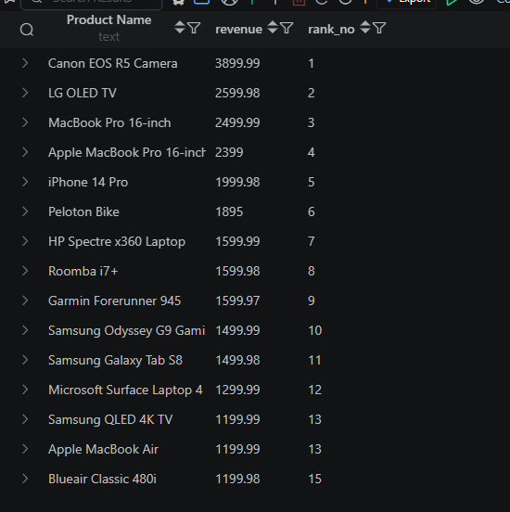

Region Revenue Ranking
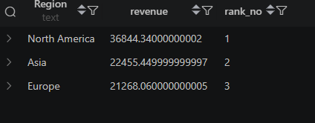

Previous Month Revenue (LAG)
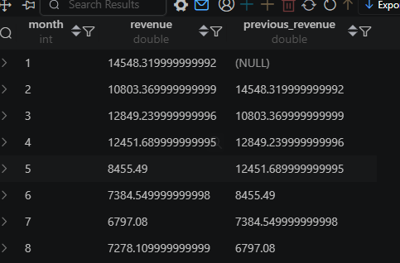

Next Month Revenue (LEAD)
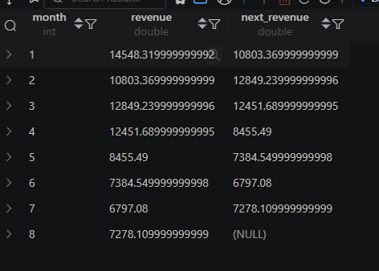

Monthly Growth Analysis
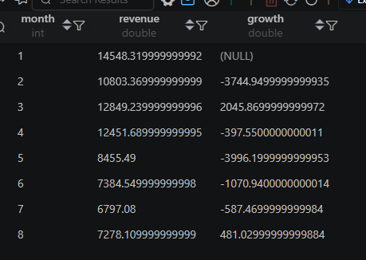

Top Product in Each Category
